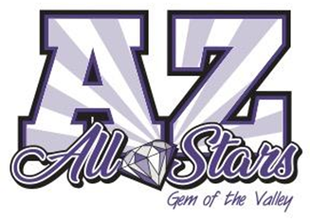
AZ ALL-STARS NOVICE CHEER TEAMS
Beginning August 11th and 12th, 2025
MINI (2016 - 2019) and JUNIOR (2010 - 2017) TEAMS AVAILABLE
Ready to take cheer to the next level and perform in uniform at competitions? Our Novice program is the BEST place to start!
Join our 1 day a week novice cheer team for $195/month*.
Program runs August 2025 -April 2026- 3-5 performances through the season
What is a NOVICE TEAM? - A novice team is for individuals who are new to All Star but ready for performance-based teams that are evaluated at events. Novice teams focus on strengthening technique and performance skills that help prepare athletes for competitive All-Star teams. Novice teams will practice 1 day a week for 1.5 hours each day. They will get a uniform and perform twice over the course of the season and participate in additional performances at the gym. Tumbling IS NOT included but can be added.
Start date - Monday, August 11th (Juniors - 6:30pm - 8pm) or Tuesday, August 12th (Mini - 4:30pm - 6pm)
Registration - $195 by Aug 1st - Gym registration, gym tank and partial choreography - If you did a TRY OUT with us in May, you do not need to register!
Register at azallstars.com/cheer
*Additional Fees - $825 - Uniform Fee (Uniform, bow), Comp fees, Sports bra, music, Choreography, additional practices - Divided into 3 payments
Tuition -
-$275 - August Tuition - Due at First practice
-$470/month - September - November - $470 each month on the 1st (Tuition $195 + 1/3 of Additional Fees)*
-$195/month - December - April 2026 - due on the 1st - Payments are withdrawn on the 1st of each month
Practice Times and Age Requirements
Mini - Birth years - 2016 - 2019 - Practice Tuesdays - 4:30pm - 6pm
Junior - Birth years - 2010 - 2017 - Practice Mondays- 6:30pm - 8pm
Tentative Competition/Performance Days in 2025/2026 - (3-4 of these dates) - 12/12, 2/27, 2/28, 3/6 or 3/7, 4/8, 4/11 - Confirmed schedule will be set at a later date.
Optional Purchases
Nfinity black cheer shoes ($145) and/or Nfinity black Sparkle Backpack with name ($135)
Optional - Additional tumbling classes can be added. Just ask the front desk
We are excited for our 2025 - 2026 NOVICE PROGRAM!!!

